I. Write objectives for section 10-2 from the essential questions on page 277
A.
B.
C.
Biology Section 10-2 part 1: The Origin of Genetics

II. CHARACTERISTICS ____________________ ON IN FAMILIES
A. D.

B. E.

C. F.

III. INHERITED CHARACTERISTICS ALSO INFLUENCED BY _____________________ OR ENVIRONMENT
A. D.

B. E.

C. F.

IV. HEREDITY: PASSING OF ____________________ FROM PARENTS TO _______________________
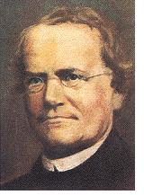
A. In ___________, Gregor ______________ performed __________________-pollination in __________________ plants
1. Austrian ________________________
2. Known as “_________________________________________________________”
a. Science of ___________________________________
B. Mendel followed various ________________ in _________ plants (Pisum sativum) he bred
1. Several characters exist in __________ clearly _____________________ forms (no intermediate forms)
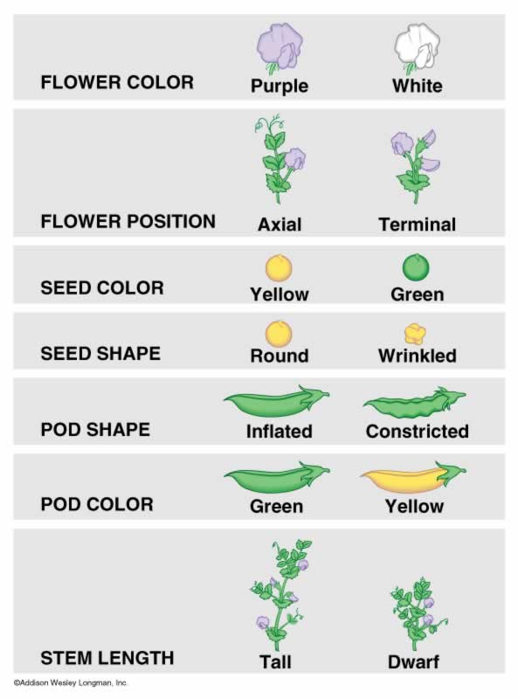
2. Male ( __________) and female (_________) reproductive parts are ________ within the ________________ flower (controls _______________________)
3. Pea is _____________________
4. Grows _____________________________
5. Matures ___________________________
6. Produces many ________________________
C. Mendel studied _________________________
different traits
V. MENDEL’S EXPERIMENT
A. ____________- pollinated for several
generations to ensure ____________-breeding
for _______________ particular character
1. Yellow peas only produce _______________
pea seed ________________________

2. ___________________ two individuals crossed called _________________________ - parental
B. Cross-pollinated ________ generation plants with ___________________________ traits
1. Yellow x (______________________) _____________________ seeds
2. Offspring = _____________ _____________________ generation (F₁ generation)
3. RECORDED number of __________ plants expressing each ____________________
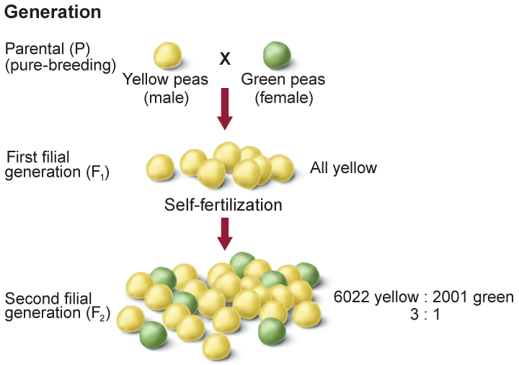
C. F₁ generation ____________________- pollinated
1. Offspring of __________ generation = second __________________ generation or F₂ generation
2. Each F₂ plant ________________________________ and ______________________

D. Overall Results
1. F₁ generation showed only ______________ form of the _________________ (yellow), contrasting trait (green) ____________________________________!
2. During F₂ generation, _______________________ trait reappeared in ___________________ plants
VI. REVIEW OF 10-2 PART 1
A. Mendel known as “Father of _______________” by his study of ______________________
B. Pea plant _______________ to breed, therefore makes ________________ subject for study
C. Although he made __________________________ discoveries in world of genetics, his work went ______________________________ for generations!
Biology Section 10-2 part 2: Mendel’s Theory and Terms

I. MOST THOUGHT __________________________ WERE A _________________ OF PARENT’S TRAITS
A. Mendel’s results did _____________ support __________________________________
1. tall plants + short plants = ____________________________________________
B. For each _________________________________ character, an individual has ____________ copies of the ________________ - one from each ______________________________
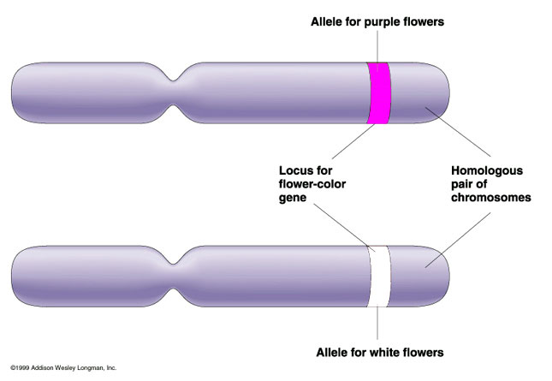
C. Alleles are __________________________________ versions of ___________________ gene
1. Each can be ______________________ on

D. Two different _______________________ occur together
1. Dominant trait is __________________________________
2. Recessive trait is _____________ expressed when __________________________ form is present

II. MENDEL’S FINDINGS IN __________________________ TERMS
A. _________________________ represent alleles
1. Dominant alleles use _______________________ letters (often the ________________ letter of character)
2. Recessive alleles use ____________________________ letters
3. For example

B. Organism with __________ of __________________ alleles for a particular trait is homozygous
1. For example, __________________ (homozygous ________________________) or ______________ (homozygous __________________________________)
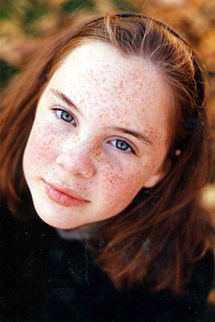
C. Organism with ________ ____________________________ alleles for a particular trait is heterozygous
1. Also called ________________________
2. For example, _____________
D. Organism’s ____________________ pairs are called its _____________________________
1. Freckles is dominant
a. Genotype can be either _______________ or _____________
E. Physical appearance or ____________________ expression of allele pair is its ______________________________
1. Having _______________________ is her phenotype
F. Mendel’s Law of _________________________________________
1. Two ___________________________ for each trait ___________________________ during ____________________________
2. During fertilization, ____________ alleles or that trait _________________________
3. Heterozygous organisms called _________________________________

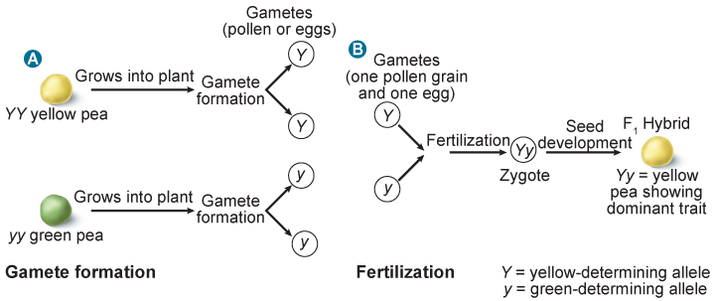

Biology Section 10-2 part 3: Genetic Problems

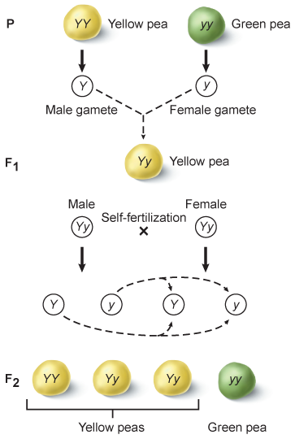
I. MONOHYBRID CROSS
A. Cross that involves __________________ for a ___________________ trait
B. Notice the ________________________ allele is always written ____________________
C. Law of Independent _________________________
1. __________________________ distribution of alleles occurs during _______________________ formation
2. Genes on ____________________ chromosomes _________________ independently during __________________________
3. Each allele combination is _____________________ likely to occur
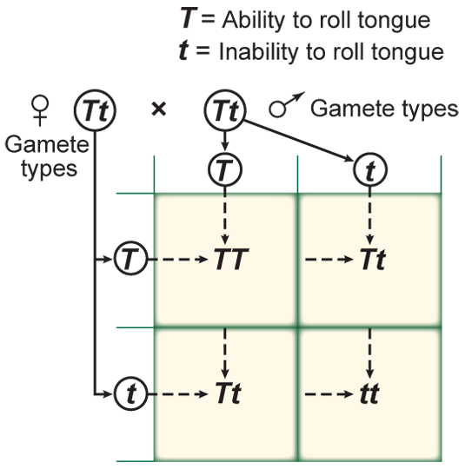
D. Punnett Square

1. Diagram that ______________________ all __________________________ outcomes of genetic crosses
2. Early 1900’s ____________________ – Reginald _________________________

II. MONOHYBRID _______________________ EXAMPLE
A. A homozygous tall pea plant is crossed (x) with a homozygous short pea
1. Assign ____________________ for traits
2. Determine parents’ __________________
3. Write possible _____________________ of one parent across ____________ and one on ________________
4. Fill in each box of Punnett square (________________________ letter first)
5. Genotype:
6. Phenotype:

B. A heterozygous dimpled female marries a heterozygous male. What are the possible outcomes of their children?
1.

2.

3. Genotypic ratio

4. Phenotypic ratio

III. DIHYBRID CROSS
A. Simultaneous inheritance of ____________ contrasting traits
B. Four types of _____________________ from male gametes and four from ______________ gametes can be produced
C. Two pea plants heterozygous for seed shape AND seed color are crossed
1.

2. Parent’s genotypes

3. Possible gametes??
a.
b. These go along ______________ and _______________ of square

4. Phenotypic ratio:

5. Typical dihybrid cross ratio: _________________________________

IV. WHY USE ___________________________________SQUARES?
A. Improve ______________________________
B. Improve ______________________________ animals
C. Determine _______________ for genetic __________________________ in infants
D. Allows to predict the expected ________________________ of genotypes of phenotypes
V. PROBABILITY IS LIKELIHOOD THAT A ________________________ EVENT WILL OCCUR
A. Expressed in ______________, decimals, ___________________ or percentages
B. Probability = # of _______________ kind of possible outcomes Total # of _____________ possible outcomes
c. _______________ parents must be considered when _____________________ probability
D. To find probability, ______________________ separate probabilities of __________ events
Biology Section 10-3: Gene Linkage and Polyploidy

I. WRITE SECTION OBJECTIVES FOR 10-3 USING ESSENTIAL QUESTIONS ON PAGE 283.
A.

B.

C.
II. GENETIC RECOMBINATION
- __________________ combination of _____________________ produced by ______________________________ over and independent assortment
1. Due to independent ___________________________ can be calculated using ____________________________________
a. n = number of chromosome ___________________________
b. Humans have _______ pairs, therefore ___________________________ ~64 ______________________ possibilities
c. Number does______________ include ________________________________
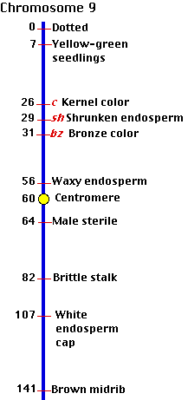
III. GENE LINKAGE
- Genes that are located __________________ to each other on ___________________ chromosome can be
____________________________
- Usually travel _______________________________________ during meiosis
- Closer genes are more ____________________________for linkage
- Exception to Mendel’s law of independent ____________________ because ______________________ genes usually do _________________ segregate independently
- Formation of chromosome __________________________
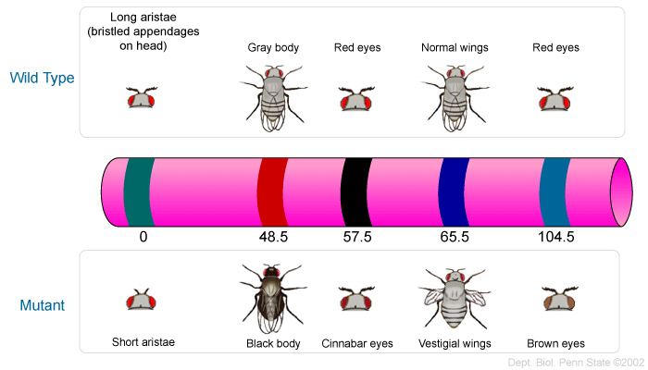
1. Shows ________________________and represents relative __________________________ of genes on a chromosome

IV. POLYPLOIDY
A. Occurrence of _____________ or more _______________ sets of __________ chromosomes in an organism
B. Triploid organism (____________) has _______________complete sets of chromosomes
C. Polyploid _____________________usually have more ______________________ traits such as ________________

A. F₂ generation B. dominant C. Recessive
F. Homozygous G. Heterozygous H. Gregor Mendel
I. P generation J. hybrid K. Reginald Punnett
M. ♂ N. ♀
______1. Another term for heterozygous
______2. Offspring of the first filial generation
______3. For example TT or tt
______4. Symbol for male
______5. Monk who studied pea plants and took detailed data
______6. Trait that is expressed ONLY when it is paired with itself
______7. Symbol for female
______8. First two individuals that are crossed are known as this
______9. Trait that is expressed when recessive form is present
_____10. For example Tt
_____11. Invented diagram that predicts all possible outcomes of genetic crosses

A. Punnett Square B. Phenotype C. Genotype
D. Monohybrid cross E. Ratio F. Heredity G. F₁ generation H. Law of Segregation I. Genetics
J. Law of independent assortment K. Dihybrid cross L. Allele
M. True breeding

_____12. Offspring of the parental generation
_____13. States that two alleles for a character separate when gametes are formed
_____14. Cross that involves ONE pair of contrasting traits
_____15. A comparison of two or more numbers
_____16. For example: she has blue eyes and blonde hair
_____17. Plants that have self-pollinated for several generations for one particular character
_____18. Branch of biology that studies heredity
_____19. Alternate versions of genes
_____20. Cross involving TWO contrasting traits
_____21. Passing of characters from parents to offspring
_____22. For example: she has Bb alleles
_____23. Diagram that predicts all possible outcomes of genetic crosses
_____24. States that alleles of different genes separate independently of one another during gamete formation

