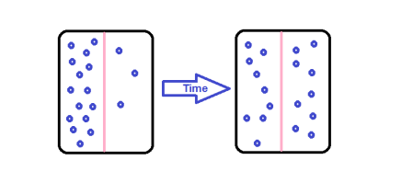**Problem:** How do substances move in and out of cells?

**Background (read aloud):** When there is a difference in concentration of a particular particle on either side of a membrane, a **concentration gradient** exists. Particles move along the concentration gradient from high to low concentration until a state of **equilibrium** is reached. At that point, there is no more net movement in one direction, although the particles continue to move randomly across the membrane, often called **dynamic equilibrium.** The net movement of particles along the concentration gradient is called **diffusion**.

1. **Try this:** Go out into the hall and in your own words, write down what happens when you spray air

freshener. How does it work? ___________________________________________________________

____________________________________________________________________________________

a. What kind of mini-experiment could you do to test your hypotheses above? Try it! What

happened? ___________________________________________________________________

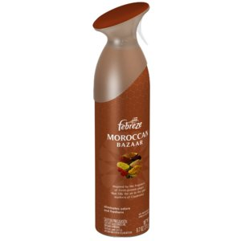 _____________________________________________________________________________

b. Draw the molecules coming out of the can.

be detailed in your drawing, showing

concentration of droplets.

2. Look back at *Models 1 and 2*. Which particles are moving by diffusion across the membranes

shown? ________________________________________________________________________

3. Using all the information from the previous models and questions circle the correct response to correctly fill in each blank.

*a.* Diffusion is the net movement of molecules from an area of (low/high) concentration to an area of (low/high) concentration.

*b.* The molecules will continue to move along this (semi-permeable membrane/ concentration gradient) until they reach (diffusion/equilibrium).

*c.* Once equilibrium is reached, molecules will continue to move across a membrane (randomly/in one direction).

***Directions:*** Use *Model 3 - Facilitated Diffusion* to answer the following questions.

4. Which part of the cell membrane is shown in more detail in Model 3? __________________________

5. What is the gap between the proteins called? ______________________________________________

6. What type of molecules attach to the protein? _____________________________________________

7. Explain in detail what happened that allowed the glucose molecules to pass through. ______________

____________________________________________________________________________________________

________________________________________________________________________________

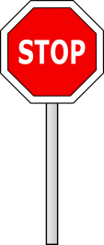 ________________________________________________________________________________

**Read This Aloud!**

Some molecules, such as glucose, use gated channels as shown in *Model 3*; however, not all channels are gated. Some channels remain permanently open and are used to transport ions and water across the cell membrane.

8. Discuss with your group why the type of protein channel in Model 3 is called a *gated channel*.

Write your group’s responses below. __________________________________________________

________________________________________________________________________________

9. To **facilitate** means to help. Explain why this type of diffusion is called facilitated diffusion. _________

________________________________________________________________________________

________________________________________________________________________________

10. The “tails” of phospholipids are nonpolar; therefore, they do not readily interact with charged particles such as ions. How can this explain why facilitated diffusion is necessary for the transport of ions such as Na+ and K+ across the cell membrane? In other words, why would these ions not

cross by simple diffusion? ___________________________________________________________

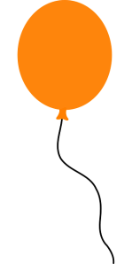 ________________________________________________________________________________

________________________________________________________________________________

**Try This!**

11. Without throwing the balloon around, make observations using your senses and write these down.

____________________________________________________________________________________

____________________________________________________________________________________

____________________________________________________________________________________

a. What kind of questions do you have? ___________________________________________________

___________________________________________________________________________________

b. Why can you smell what’s inside the balloon if it’s sealed up? _______________________________

___________________________________________________________________________________

___________________________________________________________________________________

***Directions:*** Use *Model 4- Active Transport* to answer the following questions.

12. Which part of the cell membrane is shown in more detail in Model 4? Look back at Model 2 if needed.

________________________________________________________________________________

13. What shape represents the substance being transported across the membrane in Model 4? ________

14. List two binding sites found on the protein. ________________________________________________

15. In which direction is the transported substance moving—from an area of high concentration to low or

from an area of low concentration to high? Support your answer. __________________________

________________________________________________________________________________

16. Is the substance being moved along (down) a concentration gradient? __________________ _______

Justify your answer. _______________________________________________________________

________________________________________________________________________________

17. ATP is a type of molecule that can provide energy for biological processes. Explain how the energy is

being used in Model 4. _____________________________________________________________

________________________________________________________________________________

18. What happens to the ATP after it binds to the protein?_______________________________________

19. The type of transport shown in Model 4 is called **active transport**, while diffusion and facilitated diffusion are called **passive transport**. Given the direction of the concentration gradient in active and passive transport examples, ***explain*** why active transport requires energy input by the cell.

________________________________________________________________________________

________________________________________________________________________________

________________________________________________________________________________

20. With your group, complete the table below to show the difference between active and passive transport.

|  |  |  |  |
| --- | --- | --- | --- |
|  | **Active Transport** | **Passive Transport** | |
| **Diffusion** | **Facilitated Diffusion** |
| Requires energy input by the cell |  |  |  |
| Molecules move along (down) a concentration gradient |  |  |  |
| Moves molecules against (up) a concentration gradient |  |  |  |
| Always involves channel (membrane-spanning) proteins |  |  |  |
| Molecules pass between the phospholipids |  |  |  |
| Moves ions like Na+ and K+ |  |  |  |
| Moves large molecules |  |  |  |
| Moves small nonpolar and polar molecules |  |  |  |

21. With your *group*, develop a definition for active transport. ___________________________________

________________________________________________________________________________

________________________________________________________________________________

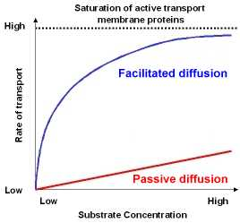

**Extension Questions**



22. Given the information in the graph, which type of cell transport would be best to move substances?

into or out of the cell quickly? _______________________________________________________

23. Which type of transport would be the best if the cell needs to respond to a sudden concentration

gradient difference? ______________________________________________________________

24. Why would the line representing facilitated diffusion level off as the concentration gets higher, while the line representing diffusion continues to go up at a steady rate?

________________________________________________________________________________

________________________________________________________________________________

25. Why does active transport, on the same graph, start off with such a high initial rate compared to

diffusion and facilitated diffusion? ____________________________________________________

 ________________________________________________________________________________

________________________________________________________________________________

**Putting it all together (this is homework!)**

26. What type of transport was shown with the air freshener and the balloon? Justify your answer.

________________________________________________________________________________

________________________________________________________________________________

________________________________________________________________________________

27. Create two enumeration (description) graphic organizers: one for passive transport and another for active transport. Be sure to include examples from this activity as well as definitions. **CHALLENGE:** Connect two organizers in a logical fashion!